FIGMA

1

**CHAPTER 2**

EXPLAIN

10 MIN1 - Go to home

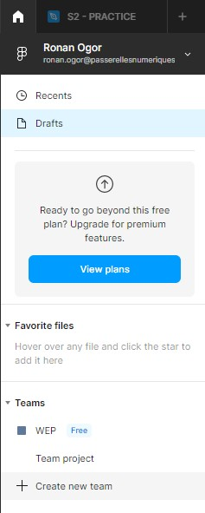

It s time to collaborate !

* Create a team of 3 students on Figma **to work together** on today activities
* **Name** your team
* Send the **link** to your teacher

2 - Create a team

EXPLAIN  What is a tangram ?

10 MIN INDIV



✓

Watch video to understand what is a tangram

✓

Learn how to design a tangram

PRACTICE

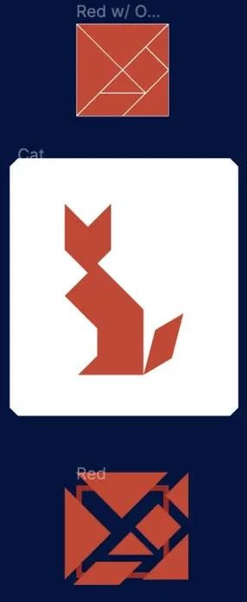

Design your

**own**

Tangram

1

–

Tangram

puzzle

Create a

**shared page with your team**

Each member add his/her

**tangram**

into this page,

with his/her

**name**

2

–

Tangram

result

3

–

Tangram

puzzle

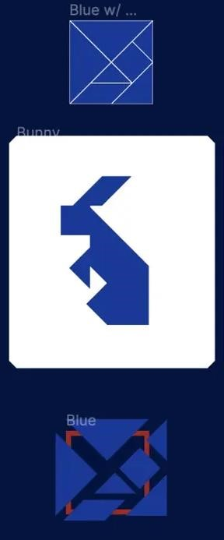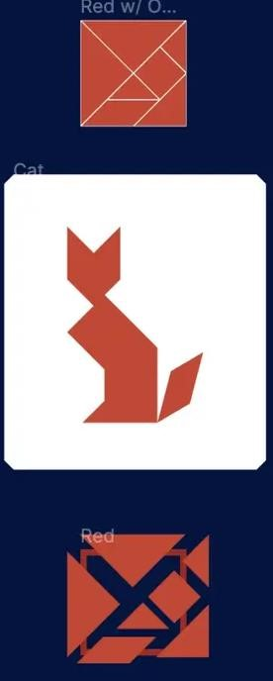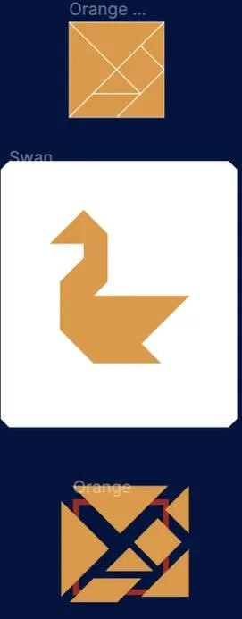

**Ronan**

**Him**

**Rady**

***STEP 2***

*In teams :*

***STEP 1***

*Individually :*

Member

name

Member

work

px

300

80

px

100

px

30 MIN



PRACTICE

30 MIN  Design a **magazine** for mobile



Your magazine must have :

*STEP 1 : In teams :*



A magazine

name

A cover image

A date

A title

An author

A body text

Frame size =

**Iphone**

**8**

* Decide in team about a **MODEL** of your magazine

*( see the specification)*

* **Create a shared page with your team**

*STEP 2 : Individually (or homework)*

* Individually, create your own magazine page, following the **MODEL**

